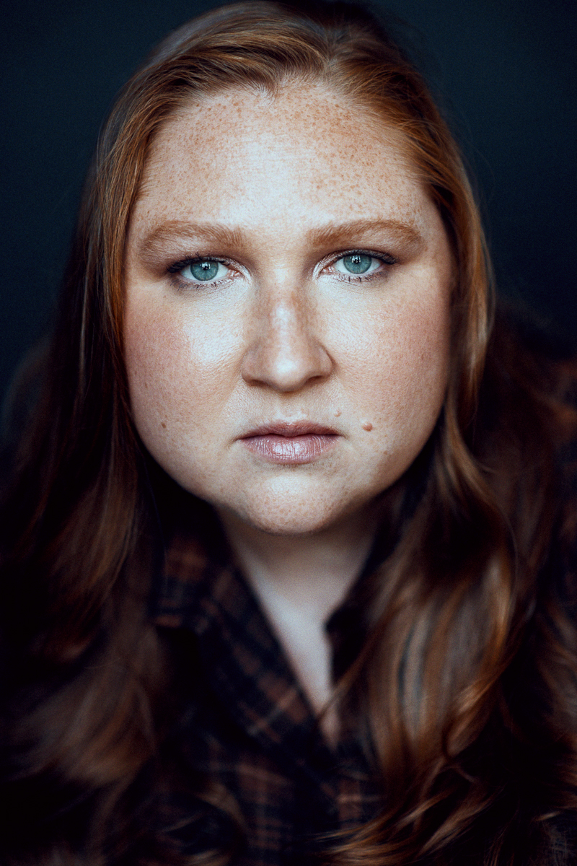
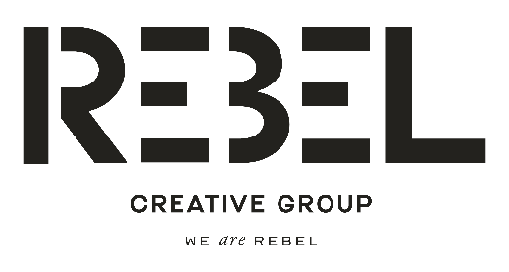
Desi Stock
Non-Union and Equity
Height: 5’6” Hair Color: Red Eye Color: Green
Contact: REBEL CREATIVE GROUP
1-310-997-0787 LOS ANGELES
1-646-461-2785 NEW YORK
SHANNON@REBELCG.COM
_______________________________________________________________ __________

TV/ Film (can be separate categories)
Larceny Dee (Lead) 186 Productions
Nanny Nightmare Trish (Lead) 186 Productions
Making It Supporting Dir. Kat Tingum
Any Moment Now Supporting One Lens Productions Yours Doubtfully, Paulina Mary (Lead) Misfit Productions Into the Dark Christie Dir. Mark Lanham

Theater
Daddy Issues Henrietta (Lead) Theatre St. Clements, NYC Off Broadway Code Strawberry Wulfa The Village Playwrights, NYC
Undefined Improv Troupe The Pit, NYC
Casual Sabbath Epona Blackbox Chicago, IL

Commercials
Conflicts available upon request

Training
On Camera Technique Theresa Pittius New York, NY
Advanced Scene Study Cady McClain New York, NY
Advanced Scene Study Michael Colby Jones New York, NY
Voiceover Anna Garduno New York, NY
Audition Technique Brette Goldstein New York, NY
__________________________________________________________________________ ____
Skills Horseback Riding, Valid License (Stick Shift), Valid Passport, Mezzo-Soprano,
REBEL CREATIVE GROUP
135 W 50TH STREET, SUITE 200 NEW YORK, NY 10020 I 9255 SUNSET BLVD. SUITE 1100 WEST HOLLYWOOD, CA 90069

